**TEST CASES.**

We have tested our program for the following test cases -

1. **Normal operation of the chat client with three clients connected**

For this use case, we have 3 clients (user1, user2, user3) in a group chat connected to the server.

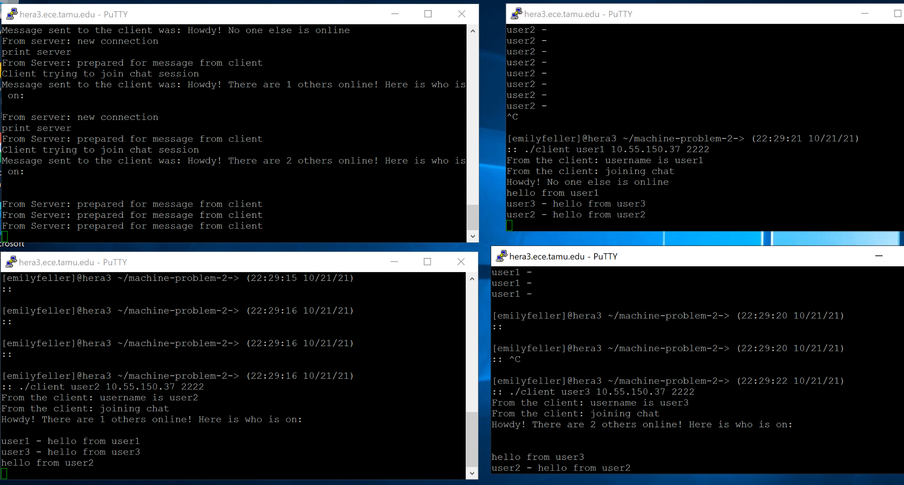

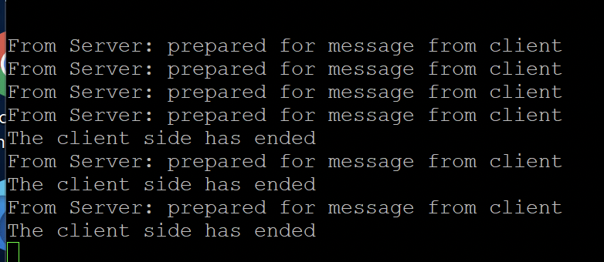

1. **Server rejects client with duplicate username**

In this use case, when the group chat already has user1 and user2. If a third client with the name user1 tries to enter the chat, it results in an error and the client has to try with a different username.

For some reason this was working, and then as we continued to make changes, stopped working. We ran out of time to get this part to work.

1. **Server allows a previously used username to be reused**

In this use case, we had user2 exit the group chat and then have another client try to join the chat with the username user2. We see that the server allows this.

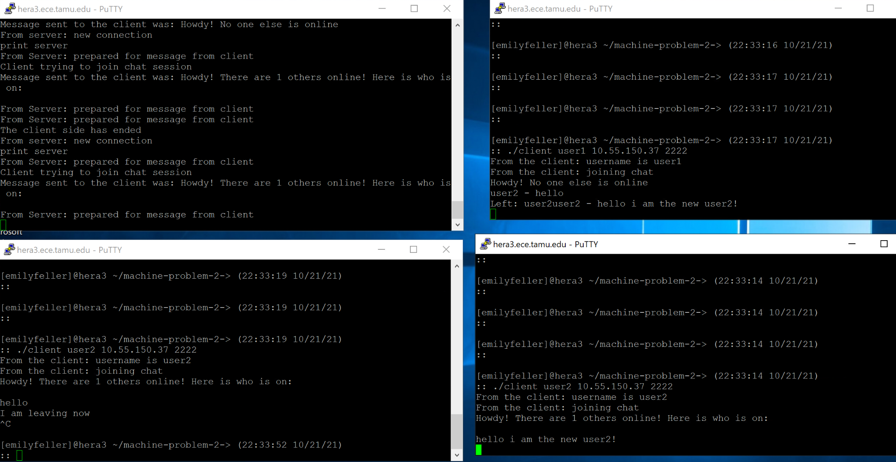

*Note Client 1 in the upper right corner: It says “Left:user2user2- hello I am the new user2!” This is missing a blank line. It supposed to say:

“Left user2

User2 - hello I am the new user2!”

Indicating that the first version of user2 left and the second one entered and sent a message

1. **Server rejects the client because it exceeds the maximum number of clients allowed**

In this use case below, the server has maximum connections allowed = 3 (including the server). If a third *client* joins the server, they get an error stating “Chat room full” and the socket is closed.

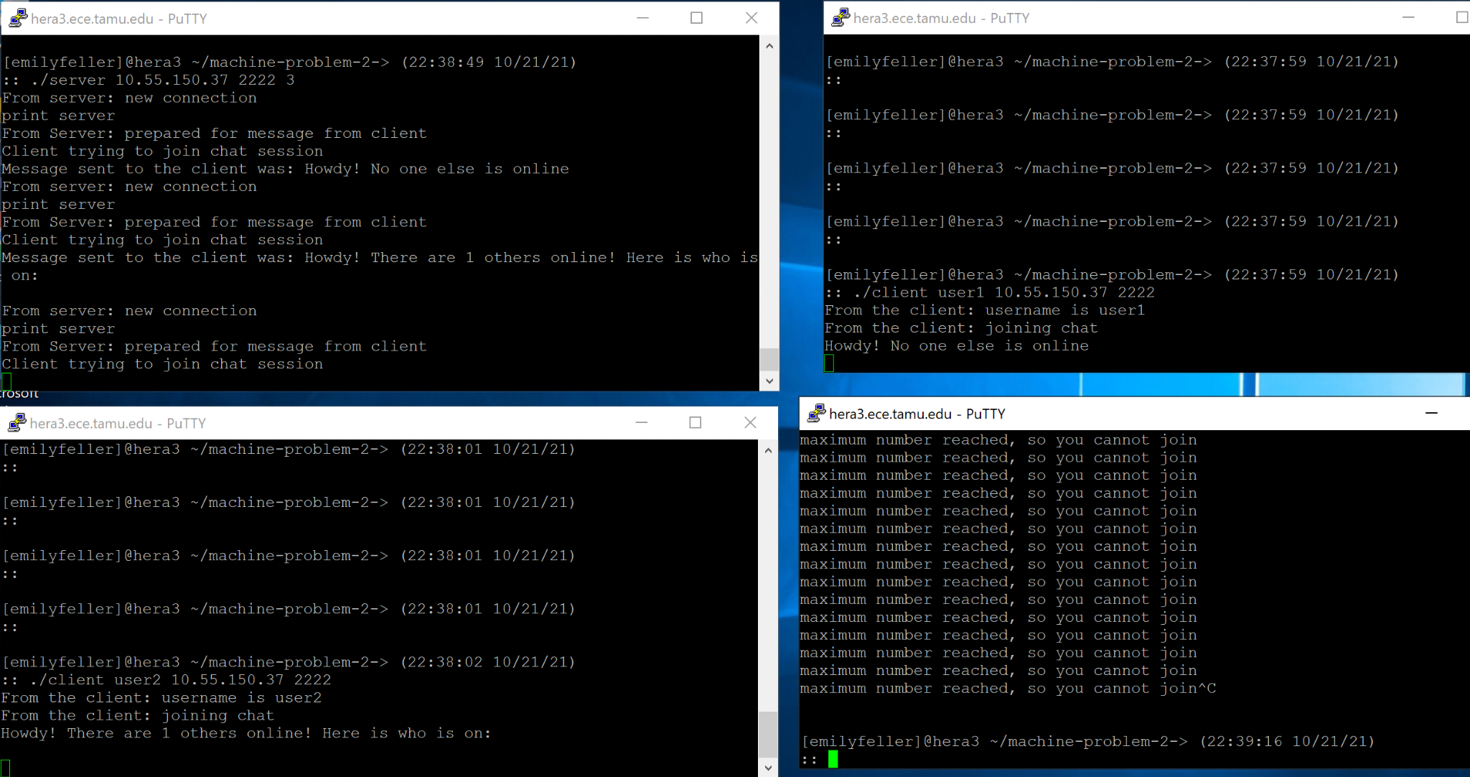

**BONUS FEATURES**

1. We made use of the Bonus header types such as 7, 5, 8 ,9. Our chat tells a client when another client has left the chat:

This is a small screenshot of indication that user2 has left. We were missing a new line character which is why it is connected to other text.

We also see the number of clients that is present in the chat wehn you join:

